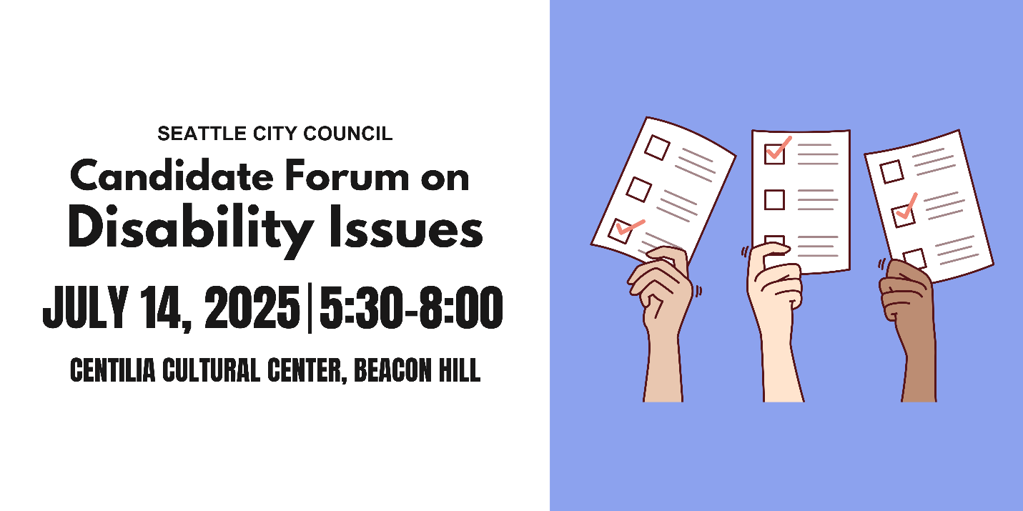
Candidate Questionnaire
Name: Eddie Lin
Position #: District 2

Campaign Statement:
Seattle can and should be an accessible, inclusive place where everyone can afford to live and thrive.

What are the top three priorities of your campaign?
1. Affordable housing and homelessness
2. Taxing wealthy corporations and individuals to meet our community’s needs
3. Defending our City’s from Trump’s attacks on immigrants, LTBQIA+, and other marginalized communities.

Representation
A popular saying in the disability community is: “nothing about us without us.” Will you commit to appointing people with disabilities to city commissions, boards, and advisory committees that impact housing, transportation, public safety, the arts, and health?
Yes Maybe No

Would you support a citywide emergency preparedness plan that includes specific strategies for reaching and supporting people with disabilities and older adults? Yes Maybe No

What will you do to ensure that city-funded agencies and public forums, including city council meetings, consistently provide qualified ASL interpreters and CART (computer aided real-time transcription)? (CART provides written subtitles in real time, usually projected on a screen). Please provide a brief response.

City Council hearings have strong accessibility provisions which include translation and interpretation services provided by the City Clerk’s office. We must prevent cuts to this agency that would threaten accessibility, and extend these services to public forums hosted by the city or outside agencies, including for things like candidate forums.

Infrastructure
Blind and low-vision pedestrians need Accessible Pedestrian Signals (APS) at street crossings. Will you commit to expanding APS installations in high-traffic and high-need areas, and involving Blind and low-vision pedestrians in the siting process?
Yes Maybe No

Would you push for disability impact assessments to be included in all major city infrastructure or policy proposals, similar to existing environmental and social and racial equity reviews?
Yes Maybe No

Scooters and e-bikes are regularly illegally parked, blocking sidewalks and creating dangerous conditions for people with mobility impairments and the Blind and low-vision community. How would you approach micromobility parking to ensure it works for everyone? Please provide a brief response.
The City can do its part by creating more micromobility parking spots throughout Seattle, so riders always have a convenient place to park that doesn’t impact accessibility. However, companies should also be on the hook to ensure riders are clearly instructed and incentivized to park devices in the correct places. In other cities, companies are required to use geofencing technology to guide users to designated parking areas and incentivize them with cheaper rides or other discounts. Additionally, some cities like San Francisco have implemented regulations on the design of vehicles which require them to be locked to a standing parking system that ensures they are not parked in the way of pedestrians. All of these interventions should be evaluated to ensure that our City is as accessible as possible. Finally, the City and these companies should conduct public education campaigns on the importance of keeping sidewalks clear.

People with disabilities are 4x less likely to drive than people without disabilities, meaning people with disabilities are more likely to commute outside of a car. Traffic deaths continue to rise every year despite Seattle’s Vision Zero goal to end traffic deaths and serious injuries by 2030. As a council member, how would you prioritize the needs of different road users to address our road safety crisis? Please provide a brief response.
The South End sees the highest rates of traffic fatalities of any district in Seattle. In particular, a handful of intersections are known problems and yet we continue to fail to see improvements to safety and infrastructure. On Council I’ll fight for the safety measures we need and expand access to multi-modal transportation options which includes bike lanes, side walks, buses, rapid-transit, light rail and more. Our Cities should not be designed for cars, but rather people!

Housing
Would you support an ordinance requiring a certain percentage of new multifamily developments to be fully accessible to people with mobility disabilities?
Yes Maybe No

Would you support an ordinance requiring a certain percentage of new multifamily developments to be fully accessible to people with intellectual or developmental disabilities (IDDs)?
Yes Maybe No

Currently, most housing that is required to be accessible under federal and state law (multifamily housing with 10 or more units; developments with 4 or more units when units are one level) is prohibited in the majority of Seattle, while stacked flats face city and state policy obstacles to economic viability. If elected, you will be responsible for finalizing Seattle’s biggest zoning reform for the next 20 years. How will you work to ensure that there is more affordable, accessible housing in Seattle? Please provide a brief response.
I’m proud to have spent the last six years working to build and fund affordable housing in Seattle. We need more housing in every neighborhood, to support our new social housing developer get off the ground quickly, and to redouble our commitments to affordable housing providers that are helping thousands of families keep a roof over their head. Some of my priorities include 1) update zoning to ensure developers can build more in every neighborhood in Seattle, not just the South End. 2) Tax massive corporations and the ultra-rich to ensure funding for affordable housing matches the increase in cost from inflation. 3) Provide more operational dollars to help housing providers with overdue repairs and staffing expenses. 4) Support tenants at risk of eviction with rental assistance and employment, mental health and substance abuse services.

41% of the chronically unhoused population in Seattle has a physical disability, compared to 17% of the non-chronically unhoused population. 37% of the chronically unhoused population in Seattle has an intellectual disability or memory impairment compared to 9% of the non-chronically unhoused population. How will you work to ensure unhoused people with disabilities receive accessible services? Please provide a brief response.
My highest priority is to create more permanent supportive housing and shelter options (including tiny home villages) that help people get inside and connected to the services they need. We need more options for services that match people’s unique needs, and studies have repeatedly shown that when folks are offered suitable housing they will choose to access it. The problem is that we do not have enough housing and shelter in general, and we particularly do not have enough suitable options for families, people with disabilities, women, children, and various groups of people suffering from specific kinds of mental health or substance abuse challenges. Working with City agencies to identify what services are needed, and how we can rapidly site shelters and permanent supportive housing in every neighborhood in Seattle is essential to address this crisis at the scale of the problem. Finally, funding for services is difficult to find and under threat due to the latest Trump tax cut bill which will impact Medicaid and Medicare. We need new local and state progressive taxes to fill the gap from the federal cuts.

Employment
Do you support city investment in job training, internships, or workforce programs specifically designed for people with intellectual and developmental disabilities?
Yes Maybe No

Would you support policies that make city employment more inclusive, such as alternative and wholistic applications or on-the-job support for candidates with disabilities?
Yes Maybe No

Health Care
The federal government recently reduced federal funding for Medicaid, a legislative decision that will disproportionately impact people with disabilities. In your capacity as a city councilmember, how would you support older adults and people with disabilities who rely on Medicaid-funded services? Please provide a brief response.
Trump’s Big Betrayal Bill will put pressure on many City services and families in Seattle. Now is a moment where we need leaders to step up and get creative with solutions that meet people’s needs. I support taxing wealthy corporations and the ultra-rich to fund the essential services we all rely on. Many of these corporations and people just got one of the largest tax cuts in US history and they can afford to foot the bill as we stand up the kind of supports that people in this city need, especially those currently relying on Medicaid or services that benefit from Medicaid.

What will you do to ensure that culturally relevant in-home care and community-based services are available and accessible to older Black adults with disabilities? How can the city expand the paid caregiver workforce and support these critical workers? Please provide a brief response.
First and foremost, caregivers aren’t paid enough and often have untenable working conditions that mean many people that would pursue a career in this industry chose not to. That is the principal reason we have such a crisis in staffing in the care industry. The city must address this through increasing prevailing wages, strengthening workplace standards, funding the Office of Labor Standards to improve conditions through investigations, and supporting caregivers in accessing the high educational qualifications that are often required. As we are addressing the staffing crisis we also need to expand city funding and public-private partnerships with community based organizations and entities that provide culturally relevant and competent care, including by working with Seattle Public Schools and our local Community Colleges. I am proudly married to a Seattle Public School teacher and union leader who helped to advocate for funding for apprenticeships in the upcoming Families, Education Preschool and Promise Levy. If elected to Council, I would push to see some of that funding go to apprenticeships for in-home health-care jobs. Particularly in the South End, there are many older BIPOC adults that do not have access to the care they need and that is a function of a systemic lack of investment in our communities and the organizations that serve us.

How do you imagine the city could support family caregivers, especially those caring for loved ones with dementia? Please provide a brief response.

The City must support organizations addressing access to services for people with dementia and work to make housing more affordable so seniors can age in place, and connected to the communities they have lived their entire lives in. When I was in high school, I lived with my grandmother who suffered from dementia at the time, and so I understand the difficulty it places on families.
An exacerbating factor for many seniors is that as they are needing more intensive care, they are also finding themselves pushed out of their homes because of skyrocketing costs. We need to do more to ensure seniors can age in place and with dignity, particularly for those managing challenging conditions like dementia. One way we can do that is to ensure we have more homes that are accessible for seniors, and to provide grants to families to make home accessibility improvements (things like ramps, widening doorways, and ADA bars for bathrooms, etc…).
Education
Would you support policies that prioritize school placement for children of Deaf parents in schools with Deaf programs and language access infrastructure, such as TOPS K-8 and Roosevelt High School?
Yes Maybe No

Recreation and Social Programs
Will you restore the staff size of Seattle Parks and Recreations Specialized Programs—which provides recreational, sporting, and social programs for people with disabilities—to pre-pandemic levels?
Yes Maybe No

Will you take steps to increase participation in Specialized Programs in South Seattle and West Seattle?
Yes Maybe No

Will you commit to rebuilding the Camp Long building that was damaged by arson, given its role in hosting the city’s only overnight summer camp for youth with disabilities?
Yes Maybe No

Would you support initiatives to create more sensory-friendly city spaces and events like quiet hours at community centers or inclusive recreational programming?
Yes Maybe No

What steps will you take to ensure the accessibility of recreational and social programs for people with disabilities? Please provide a brief response.

Expanding multi-modal transportation options that help people with disabilities get to recreational centers, cultural events, and other social programs is a must. At the same time, we need to fund and support organizations dedicated to creating more inclusive programs for people with disabilities as well. This weekend the Seattle Waterfront Park is putting on the first ever Disability Arts Festival which promises to have music, dance, visual art, spoken word and more for everyone in our community. This is the product of City funding and collaboration between parks, community organizations, and more to bring more recreational opportunities with people with disabilities. We need to double down on this kind of approach and that starts with funding but also means intentionally developing public-private partnerships to serve our accessibility goals.

Arts and Culture
What steps will you take to ensure the accessibility of the arts and cultural sector for people with disabilities? Please provide a brief response.
In addition to what I said above regarding building and funding public-private partnerships to expand programs dedicated to accessibility for people with disabilities, perhaps most importantly is that I am committed to be proactive and ready to engage and listen to disability advocates and coalition members! I look forward to learning more about how to improve access for all to arts and culture, parks and recreation, housing and all the other aspects of community life.

