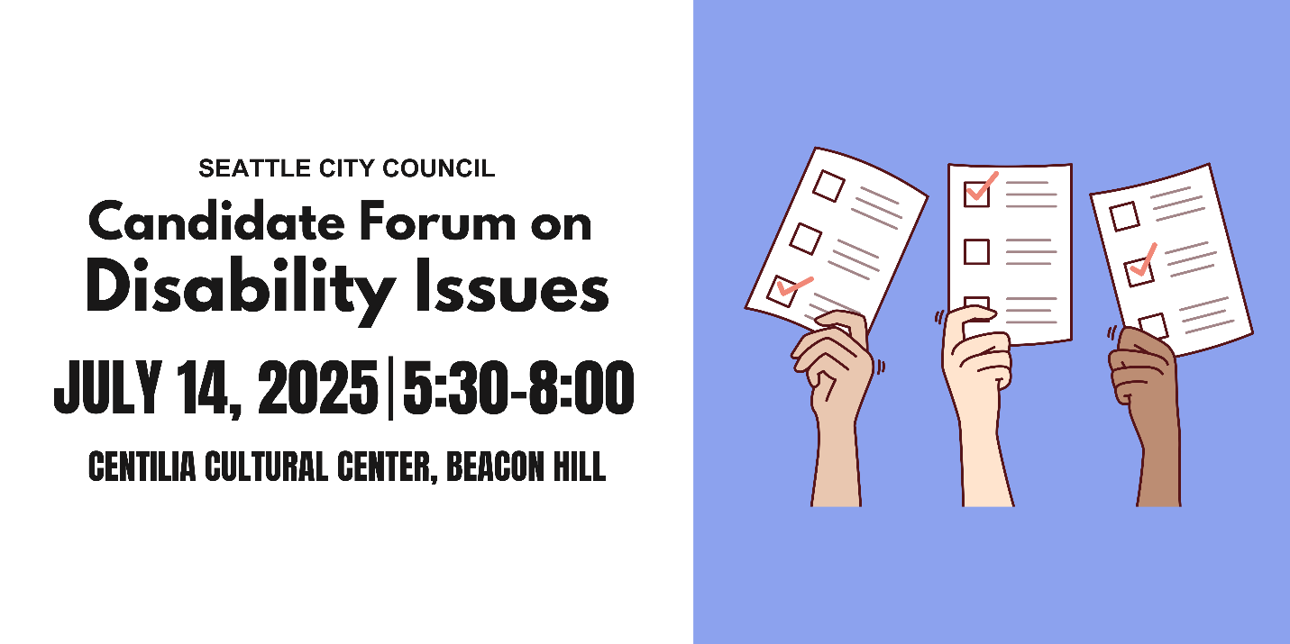
Candidate Questionnaire
Name: Jeanie Chunn
Position #: District 2 - Seattle City Council

Campaign Statement:

I believe in creating inclusive policies to build systemic change.
I am a longtime community activist and advocate that has focused on protecting small businesses in times of need and organized mutual aid for workers in crisis. The child of immigrants, mother of two, sister, niece, queer pansexual, anti-capitalist, art lover, yoga teacher, and circle work and restorative justice practitioner has given me the insight to advocate for the diverse constituencies in District 2. My campaign is forced around working class people and i have received the Working Families Party endorsement. I will work tirelessly for our city so that all folks can not only survive, but thrive.

What are the top three priorities of your campaign?
- Affordability
- Housing
- Progressive Revenue

Representation
A popular saying in the disability community is: “nothing about us without us.” Will you commit to appointing people with disabilities to city commissions, boards, and advisory committees that impact housing, transportation, public safety, the arts, and health?
Yes Maybe No

Would you support a citywide emergency preparedness plan that includes specific strategies for reaching and supporting people with disabilities and older adults? Yes Maybe No

What will you do to ensure that city-funded agencies and public forums, including city council meetings, consistently provide qualified ASL interpreters and CART (computer aided real-time transcription)? (CART provides written subtitles in real time, usually projected on a screen). Please provide a brief response.

I believe that all public forms and sites should be inclusive and consider accessibility for all folks. When i was the Director of Community Engagement, I brought online a system to increase accessibility. In addition to translating our website to over 100 languages, it had multiple other offerings to increase accessibility including a screen reader, magnification and high contrast text tools for low vision individuals, and a reading bar for folks with dyslexia. I don’t see any reason why we do not have this on all government websites to support our disabled community.

Infrastructure
Blind and low-vision pedestrians need Accessible Pedestrian Signals (APS) at street crossings. Will you commit to expanding APS installations in high-traffic and high-need areas, and involving Blind and low-vision pedestrians in the siting process?
Yes Maybe No

Would you push for disability impact assessments to be included in all major city infrastructure or policy proposals, similar to existing environmental and social and racial equity reviews?
Yes Maybe No

Scooters and e-bikes are regularly illegally parked, blocking sidewalks and creating dangerous conditions for people with mobility impairments and the Blind and low-vision community. How would you approach micromobility parking to ensure it works for everyone? Please provide a brief response.
I would work with the communities with disabilities and the apps to work together to designate areas can be safely parked. We could work together to not allow the bike to turn off until it is parked in a safe location (off the sidewalk). We can also work together to identify hubs where frequent users can find ebikes and scooters and create microparking near transit. This already is happening naturally at the PCC and Columbia City station in District 2. Perhaps, folks within the apps get points that accrue to credits for returning bikes to these parking areas.

People with disabilities are 4x less likely to drive than people without disabilities, meaning people with disabilities are more likely to commute outside of a car. Traffic deaths continue to rise every year despite Seattle’s Vision Zero goal to end traffic deaths and serious injuries by 2030. As a council member, how would you prioritize the needs of different road users to address our road safety crisis? Please provide a brief response.
I want to specifically talk about MLK in District 2. I believe that it’s important to narrow MLK. I want to work with SDOT and sound transit to make that street safer for all users. This plan would include a protected bike lane, removal of lanes to make it easier for people with disabilities to cross and slow down traffic, and planting trees to provide a shade canopy for folks walking and rolling while helping reach our climate goals. I believe in getting people out of their cars and utilizing public transportation benefits us all. In addition to this citywide, we to ensure we have safe sidewalks and Accessible Pedestrian signals for folks with disabilities.

Housing
Would you support an ordinance requiring a certain percentage of new multifamily developments to be fully accessible to people with mobility disabilities?
Yes Maybe No

Would you support an ordinance requiring a certain percentage of new multifamily developments to be fully accessible to people with intellectual or developmental disabilities (IDDs)?
Yes Maybe No

Currently, most housing that is required to be accessible under federal and state law (multifamily housing with 10 or more units; developments with 4 or more units when units are one level) is prohibited in the majority of Seattle, while stacked flats face city and state policy obstacles to economic viability. If elected, you will be responsible for finalizing Seattle’s biggest zoning reform for the next 20 years. How will you work to ensure that there is more affordable, accessible housing in Seattle? Please provide a brief response.
We are in a housing crisis and we need more housing that is affordable for everyone. I believe that we need to change our zoning to allow for stacked flats and six story buildings in every neighborhood in Seattle. In the Comprehensive Plan, we have the opportunity to add incentives and bonuses for developers who create more accessible housing for people with disabilities. Not only will this provide more housing that is affordable and accessible, this will allow small businesses to thrive and create vibrant neighborhoods so folks will not have to travel as far for daily essentials.

41% of the chronically unhoused population in Seattle has a physical disability, compared to 17% of the non-chronically unhoused population. 37% of the chronically unhoused population in Seattle has an intellectual disability or memory impairment compared to 9% of the non-chronically unhoused population. How will you work to ensure unhoused people with disabilities receive accessible services? Please provide a brief response.
I plan on expanding the CARES team into its own separate department in order for them to identify specific needs for our unhoused community. I also think it would be beneficial to explore establishing temporary housing to address the specific needs of folks with disabilities and would want to work with directly with this community to determine what care and safety look like to them.

Employment
Do you support city investment in job training, internships, or workforce programs specifically designed for people with intellectual and developmental disabilities?
Yes Maybe No

Would you support policies that make city employment more inclusive, such as alternative and wholistic applications or on-the-job support for candidates with disabilities?
Yes Maybe No

Health Care
The federal government recently reduced federal funding for Medicaid, a legislative decision that will disproportionately impact people with disabilities. In your capacity as a city councilmember, how would you support older adults and people with disabilities who rely on Medicaid-funded services? Please provide a brief response.
I would work with local disability organizations and advocates for older adults on where gaps and work to address those gaps with progressive revenue.

What will you do to ensure that culturally relevant in-home care and community-based services are available and accessible to older Black adults with disabilities? How can the city expand the paid caregiver workforce and support these critical workers? Please provide a brief response.

How do you imagine the city could support family caregivers, especially those caring for loved ones with dementia? Please provide a brief response.
Protecting dementia funding with upcoming Medicare cuts. Continuing to work interdepartmentally to support memory care events and spaces, as well as respite care for caregivers.

Education
Would you support policies that prioritize school placement for children of Deaf parents in schools with Deaf programs and language access infrastructure, such as TOPS K-8 and Roosevelt High School?
Yes Maybe No

Recreation and Social Programs
Will you restore the staff size of Seattle Parks and Recreations Specialized Programs—which provides recreational, sporting, and social programs for people with disabilities—to pre-pandemic levels?
Yes Maybe No

Will you take steps to increase participation in Specialized Programs in South Seattle and West Seattle?
Yes Maybe No

Will you commit to rebuilding the Camp Long building that was damaged by arson, given its role in hosting the city’s only overnight summer camp for youth with disabilities?
Yes Maybe No

Would you support initiatives to create more sensory-friendly city spaces and events like quiet hours at community centers or inclusive recreational programming?
Yes Maybe No

What steps will you take to ensure the accessibility of recreational and social programs for people with disabilities? Please provide a brief response.
Work with disabled community to identify what gaps we may have in accessibility for recreational and social programs.

Arts and Culture
What steps will you take to ensure the accessibility of the arts and cultural sector for people with disabilities? Please provide a brief response.
I will work closely with the office of arts and culture to ensure that not only are spaces physically accessible, but find support for audio descriptions and sign language interpreters.

