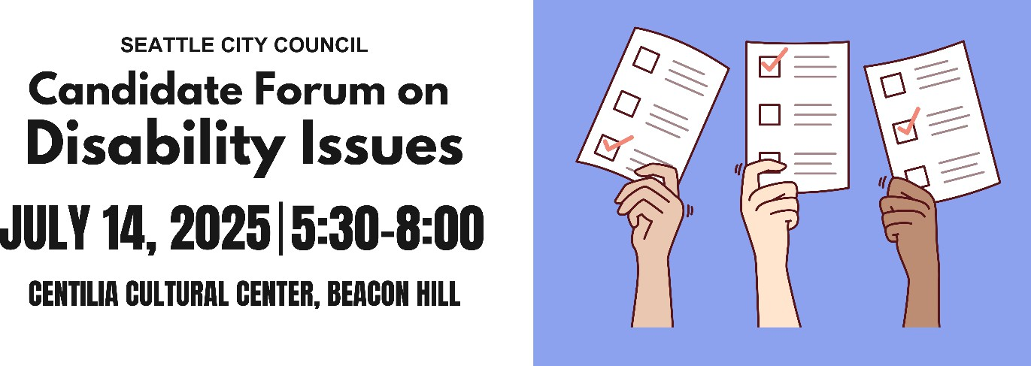

Candidate Questionnaire

Name:Dionne Foster

Position #: Seattle City Council, Position 9

Campaign Statement:

Every Seattleite deserves safe streets, affordable housing, and a Seattle that protects our rights and respects our voices. I’m running for City Council to refocus on our shared priorities and bring needed change to how our Council works. With your vote, I’ll ensure we come together to tackle national challenges and drive local progress.

What are the top three priorities of your campaign?

1. Healthy, safe communities

2.

3.

Affordable housing at every level

Thriving communities

Representation

A popular saying in the disability community is: “nothing about us without us.” Will you

commit to appointing people with disabilities to city commissions, boards, and advisory committees that impact housing, transportation, public safety, the arts, and health?

Yes

Maybe

No

Wouldyousupportacitywideemergencypreparednessplanthatincludesspecific strategies for reaching and supporting people with disabilities and older adults?

Yes Maybe No

What will you do to ensure that city-funded agencies and public forums, including city council meetings, consistently provide qualified ASL interpreters and CART (computer aided real-time transcription)? (CART provides written subtitles in real time, usually projected on a screen). *Please provide a brief response.*

As a trained social worker and former Senior Policy Advisor at the City, I know how critical it is that our public institutions are accessible to everyone. I will work to ensure that city-funded agencies and public forums—including City Council meetings—consistently provide qualified ASL interpreters and CART services.

Accessibility is not optional; it’s a matter of equity and inclusion. That means fully funding interpretation and translation services, partnering with the Deaf and disabled communities to improve standards, and holding city departments accountable to meet these commitments. Every Seattleite deserves to fully participate in our democracy.

Infrastructure

Blind and low-vision pedestrians need Accessible Pedestrian Signals (APS) at street crossings. Will you commit to expanding APS installations in high-traffic and high-need

areas, and involving Blind and low-vision pedestrians in the siting process?

Yes

Maybe

No

Would you push for disability impact assessments to be included in all major city infrastructureorpolicyproposals,similartoexistingenvironmentalandsocialandracial

equity reviews?

Yes

Maybe

No

Scooters and e-bikes are regularly illegally parked, blocking sidewalks and creating dangerous conditions for people with mobility impairments and the Blind and low-vision community. How would you approach micromobility parking to ensure it works for everyone? *Please provide a brief response.*

Everyone should be able to navigate our city safely. We need accessible sidewalks

—not ones blocked by scooters and e-bikes. Earlier this year some of the micromobility companies began deploying foot patrol staff to address parking and other issues, however those patrols are only in certain parts of the city and we need to ensure our sidewalks are safe and clear in every neighborhood. I’m interested in exploring additional solutions including - stronger enforcement of micromobility parking rules, designated parking zones and other community informed suggestions.

People with disabilities are 4x less likely to drive than people without disabilities, meaning people with disabilities are more likely to commute outside of a car. Traffic deaths continue to rise every year despite Seattle’s Vision Zero goal to end traffic deaths and serious injuries by 2030. As a council member, how would you prioritize the needs of different road users to address our road safety crisis? *Please provide a brief response.*

As a Councilmember, I’ll prioritize achieving the goals in Vision Zero including redesigning dangerous streets, and ensuring sidewalks, crosswalks, and transit are safe and accessible. I will champion the work of the Transportation taskforce intended to focus on recommendations for improving and increasing sidewalks. I will also partner with Metro and others to improve our bus reliability, safety and frequency so that riders can get where they need to go when they need to get there.

Housing

Would you support an ordinance requiring a certain percentage of new multifamily

developments to be fully accessible to people with mobility disabilities?

Yes

Maybe

No

Would you support an ordinance requiring a certain percentage of new multifamily developments to be fully accessible to people with intellectual or developmental disabilities (IDDs)?

Yes Maybe No

Currently, most housing that is required to be accessible under federal and state law (multifamily housing with 10 or more units; developments with 4 or more units when units are one level) is prohibited in the majority of Seattle, while stacked flats face city and state policy obstacles to economic viability. If elected, you will be responsible for finalizing Seattle’s biggest zoning reform for the next 20 years. How will you work to ensure that there is more affordable, accessible housing in Seattle? *Please provide a brief response.*

Everyone deserves a home they can afford and access. As a Councilmember, I’ll champion zoning reforms that legalize more affordable, accessible housing in every neighborhood—including stacked flats and multi-level buildings with accessible units. I also recognize stacked flats are not a perfect or sole solution given that in buildings without an elevator it is only the bottom floor that is accessible. I’m committed to ongoing learning and partnership in governance to make sure we update our zoning regulations and encourage and support development that works for everyone.

41% of the chronically unhoused population in Seattle has a physical disability, compared to 17% of the non-chronically unhoused population. 37% of the chronically unhoused population in Seattle has an intellectual disability or memory impairment compared to 9% of the non-chronically unhoused population. How will you work to ensure unhoused people with disabilities receive accessible services? *Please provide a brief response.*

We must meet people where they are—with services that are accessible,

trauma-informed, and rooted in dignity. As a Councilmember, I’ll push to ensure our facilities are designed for accessibility and I will focus our homelessness response on services and treatment, not on criminalization. I will invest in permanent supportive

housing, and ensure shelters and outreach programs are physically and cognitively accessible.

Employment

Do you support city investment in job training, internships, or workforce programs

specifically designed for people with intellectual and developmental disabilities?

Yes

Maybe

No

Would you support policies that make city employment more inclusive, such as

alternative and wholistic applications or on-the-job support for candidates with disabilities?

Yes

Maybe

No

Health Care

The federal government recently reduced federal funding for Medicaid, a legislative decision that will disproportionately impact people with disabilities. In your capacity as a city councilmember, how would you support older adults and people with disabilities who rely on Medicaid-funded services? *Please provide a brief response.*

Cuts to Medicaid are cruel and short-sighted. As a City Councilmember, I’ll advocate for local investments to help fill gaps in care, expand support for community-based providers, and work with state and county partners to protect vital services. I will also be a vocal partner for changes in our state tax code and investments at the state level to backfill cuts to Medicaid. I know from personal experience how critical Medicaid/Apple Health coverage is and I will be a dedicated partner in the fight for healthcare.

What will you do to ensure that culturally relevant in-home care and community-based services are available and accessible to older Black adults with disabilities? How can

the city expand the paid caregiver workforce and support these critical workers? *Please provide a brief response.*

Last year, as a member of Defend Washington, I supported protecting Washington Cares at the ballot because I know how critical investments in long-term care services are. In 2026 family members will begin being able to access paid caregiving through Washington Cares. As a Councilmember, I’ll fight for culturally relevant,

community-based care rooted in trust and dignity—especially for older Black adults with disabilities who are too often underserved. I’ll support funding for BIPOC-led service providers, expand pathways into the caregiving workforce with living wages and benefits, and invest in training programs that reflect the communities they serve. Care work is essential work, and our policies should treat it that way.

How do you imagine the city could support family caregivers, especially those caring for loved ones with dementia? *Please provide a brief response.*

Family caregivers are the backbone of our care system—and they deserve real support. As a Councilmember, I’ll advocate for expanded respite care, caregiver support programs, and partnerships with community organizations that serve families impacted by dementia. We must invest in resources, training, and financial support so caregivers aren’t carrying this burden alone.

Education

Would you support policies that prioritize school placement for children of Deaf parents in schools with Deaf programs and language access infrastructure, such as TOPS K-8

and Roosevelt High School?

Yes

Maybe

No

Recreation and Social Programs

Will you restore the staff size of Seattle Parks and Recreations Specialized Programs—which provides recreational, sporting, and social programs for people with disabilities—to pre-pandemic levels?

Yes Maybe No

Will you take steps to increase participation in Specialized Programs in South Seattle

and West Seattle?

Yes

Maybe

No

Will you commit to rebuilding the Camp Long building that was damaged by arson, given its role in hosting the city’s only overnight summer camp for youth with

disabilities?

Yes

Maybe

No

Would you support initiatives to create more sensory-friendly city spaces and events like

quiet hours at community centers or inclusive recreational programming?

Yes

Maybe

No

What steps will you take to ensure the accessibility of recreational and social programs for people with disabilities? *Please provide a brief response.*

As a Councilmember, I will work to improve accessibility in all city-funded recreational and social programs—from facilities and transportation to communication access like ASL and CART. I’ll partner with the leaders and disability advocates to remove barriers and ensure inclusion is built into every program from the start. I’ll support the ‘Specialized Programs’ team within the Parks Department and protect the resources for scholarships that help make those programs available to people across income levels.

Arts and Culture

What steps will you take to ensure the accessibility of the arts and cultural sector for people with disabilities? *Please provide a brief response.*

As a Councilmember, I’ll champion funding and policies that make Seattle’s arts and cultural spaces accessible to all—physically, financially, and culturally. That means investing in ADA-compliant venues, ensuring access to ASL, CART, and

sensory-friendly programming, and supporting disabled artists and audiences. Arts and culture should reflect and include everyone in our community.