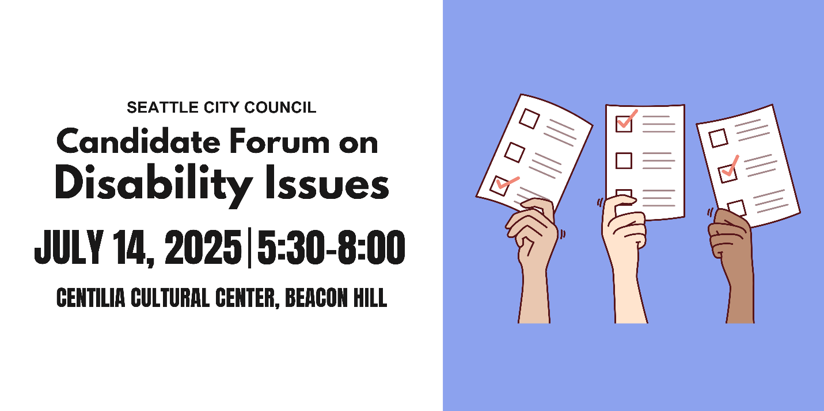
Candidate Questionnaire
Name: Jamie Fackler
Position #: Seattle City Council D2

Campaign Statement:
Seattle is one of the richest cities on the planet, but it doesn’t feel that way. We’ve got billionaires dodging taxes while families go without the basics. This isn’t a crisis of resources, it’s a crisis of priorities.
Working families used to buy homes here and thrive. We don’t have to accept the new status quo. I’m running to create a Seattle where everyone has a home, every kid feels safe walking to school, and where our communities are filled with hope.
I support Social Housing to provide high-quality, union built housing as a public good. I’ll expand opportunities for permanently affordable housing, protect tenant rights, and build shelter capacity. My office will expand the Care Team and support organizations working to solve our drug and mental health crisis. We’ll refuse to accept a police contract without accountability measures, fund diversion programs, and restore feelings of safety in our city. I’m not a career politician, but our city deserves to have regular people in city hall.
Endorsements: King County Democrats, 37th District Democrats, County Councilmember Teresa Mosqueda, Tammy Morales, Larry Gossett, MLK Labor, PROTEC17, ILWU19, ATU587, SUP, IAM751, AFT Washington, UAW4121. I’d be honored if you supported me too.

What are the top three priorities of your campaign?
1.Affordable Housing for All
2. Road safety in the rainier valley particularly at the at grade light rail stations
3. Real solutions to the our homeless and drug crisis by investing in shelters, treatment and mental health services

Representation
A popular saying in the disability community is: “nothing about us without us.” Will you commit to appointing people with disabilities to city commissions, boards, and advisory committees that impact housing, transportation, public safety, the arts, and health?
Yes

Would you support a citywide emergency preparedness plan that includes specific strategies for reaching and supporting people with disabilities and older adults? Yes

What will you do to ensure that city-funded agencies and public forums, including city council meetings, consistently provide qualified ASL interpreters and CART (computer aided real-time transcription)? (CART provides written subtitles in real time, usually projected on a screen). Please provide a brief response.

Public meetings should be accessible to all. That we are not currently providing interpretation services and real time subtitles is disappointing. I will do my best to provide these services at my committee meetings and push to have them at all council meetings.

Infrastructure
Blind and low-vision pedestrians need Accessible Pedestrian Signals (APS) at street crossings. Will you commit to expanding APS installations in high-traffic and high-need areas, and involving Blind and low-vision pedestrians in the siting process?
Yes

Would you push for disability impact assessments to be included in all major city infrastructure or policy proposals, similar to existing environmental and social and racial equity reviews?
Yes

Scooters and e-bikes are regularly illegally parked, blocking sidewalks and creating dangerous conditions for people with mobility impairments and the Blind and low-vision community. How would you approach micromobility parking to ensure it works for everyone? Please provide a brief response.
We should require designated parking outside the accessible path of travel. These devices are not supposed to be ridden on sidewalks, so why are they allowed to park there? Requiring street parking stalls for Lime and other scooter/bike rental services seems like a logical solution.

People with disabilities are 4x less likely to drive than people without disabilities, meaning people with disabilities are more likely to commute outside of a car. Traffic deaths continue to rise every year despite Seattle’s Vision Zero goal to end traffic deaths and serious injuries by 2030. As a council member, how would you prioritize the needs of different road users to address our road safety crisis? Please provide a brief response.
I have been hit as a pedestrian and a bicyclist. Everyone deserves to make it home safe. Protecting our most vulnerable road and sidewalk users should be a paramount duty. I will continue to advocate for improving protections for pedestrians on MLK and Rainier. SDOT and Sound Transit need to provide simple gates at train crossings to protect pedestrians and cars from impacts with trains. SODO crossings on Link line 1 have gates that drop to prevent collisions, so do the new stations in Bellevue. Residents of SE Seattle deserve these simple safety measures too.

Housing
Would you support an ordinance requiring a certain percentage of new multifamily developments to be fully accessible to people with mobility disabilities?
Yes

Would you support an ordinance requiring a certain percentage of new multifamily developments to be fully accessible to people with intellectual or developmental disabilities (IDDs)?
Yes

Currently, most housing that is required to be accessible under federal and state law (multifamily housing with 10 or more units; developments with 4 or more units when units are one level) is prohibited in the majority of Seattle, while stacked flats face city and state policy obstacles to economic viability. If elected, you will be responsible for finalizing Seattle’s biggest zoning reform for the next 20 years. How will you work to ensure that there is more affordable, accessible housing in Seattle? Please provide a brief response.
Advocating for changes to the building code to make stacked flats economically viable is a priority. I would push to change townhome development in NC zoning to required to have a first floor that is accessible. The current zoning code allows developers to elevate the first floor and skirt accessibility requirements.

41% of the chronically unhoused population in Seattle has a physical disability, compared to 17% of the non-chronically unhoused population. 37% of the chronically unhoused population in Seattle has an intellectual disability or memory impairment compared to 9% of the non-chronically unhoused population. How will you work to ensure unhoused people with disabilities receive accessible services? Please provide a brief response.
Requiring accessibility is something that we should look at codifying in city Law. I’m not sure of the legal aspects of this but a law that requires compliance with the ADA seems a reasonable approach. I would like to meet with your advocates and further understand what can be done to strengthen ADA accessibility compliance.

Employment
Do you support city investment in job training, internships, or workforce programs specifically designed for people with intellectual and developmental disabilities?
Yes

Would you support policies that make city employment more inclusive, such as alternative and wholistic applications or on-the-job support for candidates with disabilities?
Yes

Health Care
The federal government recently reduced federal funding for Medicaid, a legislative decision that will disproportionately impact people with disabilities. In your capacity as a city councilmember, how would you support older adults and people with disabilities who rely on Medicaid-funded services? Please provide a brief response.
I will push for progressive revenue the back fill the federal cuts in Medicaid. A capital gains tax modeled on the state tax would be a start.

What will you do to ensure that culturally relevant in-home care and community-based services are available and accessible to older Black adults with disabilities? How can the city expand the paid caregiver workforce and support these critical workers? Please provide a brief response.
Expanding the work force will likely require new revenue. This should be progressive revenue and i would push to fund this with a capital gains tax. We also should support the development of caregivers with training. Partnering with our community colleges to provide the training seems reasonable.

How do you imagine the city could support family caregivers, especially those caring for loved ones with dementia? Please provide a brief response.
I can imagine that this is a heavy burden for folks. I know that there are staffing challenges at the City of Seattle HSD. This seems like the department best suited to provide the support for family caregivers. We should ensure adequate staffing levels at HSD so caseloads are manageable and staff are able to provide supports.

Education
Would you support policies that prioritize school placement for children of Deaf parents in schools with Deaf programs and language access infrastructure, such as TOPS K-8 and Roosevelt High School?
Yes

Recreation and Social Programs
Will you restore the staff size of Seattle Parks and Recreations Specialized Programs—which provides recreational, sporting, and social programs for people with disabilities—to pre-pandemic levels?
Yes

Will you take steps to increase participation in Specialized Programs in South Seattle and West Seattle?
Yes

Will you commit to rebuilding the Camp Long building that was damaged by arson, given its role in hosting the city’s only overnight summer camp for youth with disabilities?
Yes

Would you support initiatives to create more sensory-friendly city spaces and events like quiet hours at community centers or inclusive recreational programming?
Yes

What steps will you take to ensure the accessibility of recreational and social programs for people with disabilities? Please provide a brief response.
Again we should enshrine disability rights in city law. This should not have to be a continued fight for advocates.

Arts and Culture
What steps will you take to ensure the accessibility of the arts and cultural sector for people with disabilities? Please provide a brief response.
Tying grant funding to minimum accessibility requirements.

