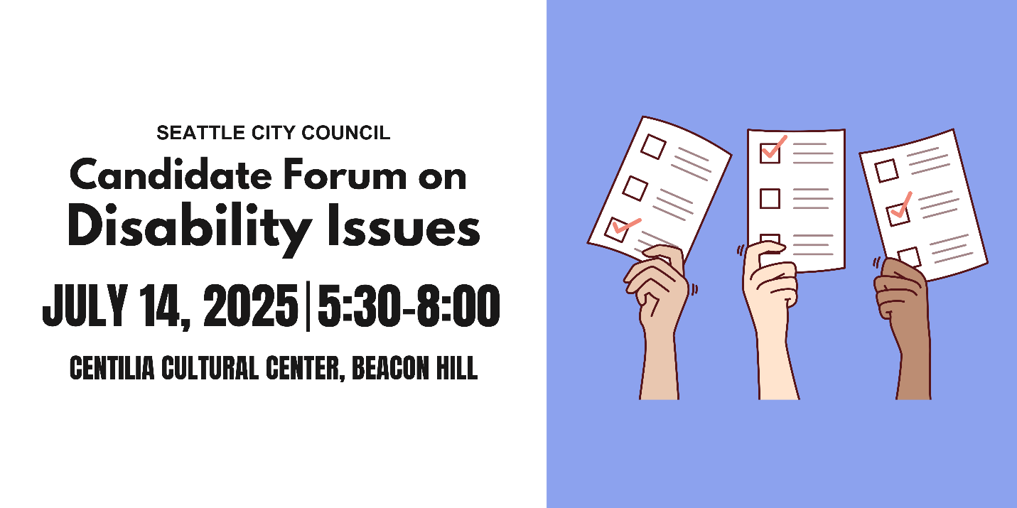
Candidate Questionnaire
Name: Adonis Ducksworth
Position #: 2

Campaign Statement:
I am running because I want to make life better for kids and families in Southeast Seattle. This starts with supporting them with living wages, meaningful job opportunities, affordable housing, access to quality education, safe and accessible transportation, and healthy and nurturing activities.
I am the best candidate for your members because I have shared the experience of many working people who worked hard to obtain an education, earn a graduate degree, and pursue meaningful work. I grew up in a small apartment with my mother on Beacon Hill and attended school in Southeast Seattle. I went on to attend Seattle Central College and then the UW Tacoma as an undergrad and UW Seattle for graduate school. Before attending college, I worked in restaurants, as a DJ, and as an undergrad, I made ends meet by working in the Learning Center as a writing consultant. As a graduate student at the Evans School of Public Policy and Governance, I worked as a Research Assistant for Professor Richard Zerbe, assisting in data collection and analysis of economic data related to emergency management.
I still live in Southeast Seattle with my wife where we are raising our two daughters. I work for the City of Seattle where I am a proud Protec17 Union member. I worked for the Seattle Department of Transportation as an outreach and engagement lead and today I work as a transportation advisor to the Mayor.
My lived experiences help inform my commitment to building a Seattle where all workers, including academic student employees, postdocs, and researchers, have the support, protections, and opportunities they need to thrive. As some whose family is supported by union wages and protections, I understand the importance of equitable labor policies, affordable housing, and public investment in education and research. If elected, I will advocate for stronger worker protections, including fair wages, job security, and expanded benefits.

What are the top three priorities of your campaign?
1. Public safety: I will fund community-based organizations that work with victims of gun violence to help restore a sense of belonging and safety within the community. I will focus police recruitment on hiring people directly from the community, whose close ties will increase the care and safety of the community. For our kids, I also plan to partner with gun violence prevention advocates to build programs that keep youth away from crime and will scale up safer routes to schools, playgrounds, and parks. Lastly, I will work to provide small businesses with protection from crime so they can stay open and protected.
2. Housing affordability: I will implement the Comprehensive Plan to equitably expand different types of housing in Southeast Seattle, advance anti-displacement policies to protect our diverse communities and maintain generational wealth opportunities, scale up services to provide unhoused people with safe temporary and then permanent shelter, and correct the historical injustices to marginalized communities in Southeast Seattle caused by zoning policies by working with organizations to support homeownership for marginalized people and improve infrastructure and community spaces in the district.
3. Transportation reliability: I plan to prioritize and invest the 2024 Transportation Levy dollars in improving the safety for cars, pedestrians, and bikers on two of Seattle’s most dangerous roads: Martin Luther King Jr Way S and Rainier Avenue S. Furthermore I want to speed up construction on sidewalk and road projects so that transit, both private and public, can move swiftly throughout the city. Lastly, I plan on working with the Transportation Levy dollars to make our buses, light rails, and other public transportation infrastructure be more consistent, faster, and safer for all riders.

Representation
A popular saying in the disability community is: “nothing about us without us.” Will you commit to appointing people with disabilities to city commissions, boards, and advisory committees that impact housing, transportation, public safety, the arts, and health?
Yes Maybe No

Would you support a citywide emergency preparedness plan that includes specific strategies for reaching and supporting people with disabilities and older adults? Yes Maybe No

What will you do to ensure that city-funded agencies and public forums, including city council meetings, consistently provide qualified ASL interpreters and CART (computer aided real-time transcription)? (CART provides written subtitles in real time, usually projected on a screen). Please provide a brief response.

Every person deserves to be able to engage in city-funded and public services. I support initiatives to gather and allocate funding to provide interpreters and transcription services so that access to important events and information can be expanded. I also believe it is important to connect and engage with the deaf and hard-of-hearing community in order to make sure that they feel understood and accommodate by our plans and actions.

Infrastructure
Blind and low-vision pedestrians need Accessible Pedestrian Signals (APS) at street crossings. Will you commit to expanding APS installations in high-traffic and high-need areas, and involving Blind and low-vision pedestrians in the siting process?
Yes Maybe No

Would you push for disability impact assessments to be included in all major city infrastructure or policy proposals, similar to existing environmental and social and racial equity reviews?
Yes Maybe No

Scooters and e-bikes are regularly illegally parked, blocking sidewalks and creating dangerous conditions for people with mobility impairments and the Blind and low-vision community. How would you approach micromobility parking to ensure it works for everyone? Please provide a brief response.
Public safety is important to me and a big part of that is pedestrian safety, especially near or around streets or busy traffic areas. Sidewalks are something that can easily be improved for pedestrian safety and illegally parked scooters and e-bikes contributing to that problem need to be addressed. We can create more clearly marked designated parking areas for these vehicles so that the dangers to pedestrians of all abilities can be reduced.

People with disabilities are 4x less likely to drive than people without disabilities, meaning people with disabilities are more likely to commute outside of a car. Traffic deaths continue to rise every year despite Seattle’s Vision Zero goal to end traffic deaths and serious injuries by 2030. As a council member, how would you prioritize the needs of different road users to address our road safety crisis? Please provide a brief response.
I’ve spent the last decade working to improve transit access and services throughout Seattle, and improve safety and mobility in our neighborhoods. I’m proud to have been one of the key architects of last year’s voter-approved Seattle Transportation Levy – and on Council I’ll make sure we get the resources we deserve to keep all people moving.
Public safety on our transit system must be a top priority — not just for passengers, but also for drivers, pedestrians, and everyone who moves through our city. I have spent the last 15 years or so working to improve transit access and services throughout Seattle and to increase safety and mobility in our neighborhoods.
Addressing security concerns for the drivers and passengers starts with an increased presence of uniformed and non-uniformed King County Metro Transit officers and Seattle Police Department officers on and off the bus and in, near, and around transit stops. The Seattle Transit Measure expires in 2027, and I will be your advocate to push for the Executive to pursue another Measure. STM dollars will be used to increase security on and near bus stops. I will also direct STM dollars to make infrastructure improvements at the transit stops that increase lighting and discourage loitering and illegal behavior.
Furthermore, we need to address the safety of our roads. I will prioritize and invest 2024 Transportation Levy dollars in improving pedestrian, bike, and traffic safety on Rainier Ave and MLK by rebuilding sidewalks, slowing cars down, and installing better lighting, signals, and crosswalks. I will work to scale up and expedite construction of new sidewalks, curb ramps, and traffic calming devices that slow cars down on our side streets in our neighborhoods. I will demand action on the MLK Link Light rail dangers that harm too many people. We need a voice to work with Sound Transit. I'd ask to serve on the Board and bring South Seattle priorities directly to the table and provide a long-term, structural redesign to at-grade crossings that are simply not safe or sustainable. I promise to fight to protect and enhance Metro service and safety for drivers and passengers.
Lastly, I will support and expedite more permits for People Streets, Block Parties, and Play Streets so we can safely celebrate each other and our diverse neighbors.

Housing
Would you support an ordinance requiring a certain percentage of new multifamily developments to be fully accessible to people with mobility disabilities?
Yes Maybe No

Would you support an ordinance requiring a certain percentage of new multifamily developments to be fully accessible to people with intellectual or developmental disabilities (IDDs)?
Yes Maybe No

Currently, most housing that is required to be accessible under federal and state law (multifamily housing with 10 or more units; developments with 4 or more units when units are one level) is prohibited in the majority of Seattle, while stacked flats face city and state policy obstacles to economic viability. If elected, you will be responsible for finalizing Seattle’s biggest zoning reform for the next 20 years. How will you work to ensure that there is more affordable, accessible housing in Seattle? Please provide a brief response.
Ensuring that everyone can afford to live in the communities where they work, raise their families, and build their future is important in making Seattle equitable and livable. I’m running for City Council to be a voice for these priorities, advocating for housing affordability, transit access, and policies that prevent displacement while mitigating climate impact.
I was raised by a single mother in a triplex home just off Beacon Ave, where access to an affordable rental near schools and services was essential to my family’s stability. She had to work two jobs just to make ends meet. My mother and I would not be able to live in Seattle today under the same circumstances. Today, too many families are struggling to stay in Seattle, facing rising costs and displacement pressures.
That’s why I will implement changes to the city’s housing and growth plan to equitably expand affordable, workforce, low-income, and social housing– focusing on the needs of D2 communities, and demanding a true citywide approach to ensure the density, equity, and anti-displacement strategies needed across Seattle. I will advance policies that protect longtime residents, community diversity, and support aging in place. I will partner with organizations that promote homeownership for historically marginalized communities like the Black Legacy Homeowners. I will be a tireless advocate to correct the long-standing harm caused by redlining and exclusionary zoning and push for investments in infrastructure, parks, and green spaces to create healthier, climate-friendly neighborhoods.

41% of the chronically unhoused population in Seattle has a physical disability, compared to 17% of the non-chronically unhoused population. 37% of the chronically unhoused population in Seattle has an intellectual disability or memory impairment compared to 9% of the non-chronically unhoused population. How will you work to ensure unhoused people with disabilities receive accessible services? Please provide a brief response.
Far too many of our unhoused neighbors with disabilities face compounding barriers to shelter, services, and support. As a Councilmember, I will prioritize deeply affordable and supportive housing options with embedded accessibility features. I will advocate for expanded outreach programs that include disability-trained staff and ensure our homelessness response system uses universal design standards in shelters and service sites. I will also push for better coordination between service providers, public health, and disability rights organizations to create a more holistic and responsive system.

Employment
Do you support city investment in job training, internships, or workforce programs specifically designed for people with intellectual and developmental disabilities?
Yes Maybe No

Would you support policies that make city employment more inclusive, such as alternative and wholistic applications or on-the-job support for candidates with disabilities?
Yes Maybe No

Health Care
The federal government recently reduced federal funding for Medicaid, a legislative decision that will disproportionately impact people with disabilities. In your capacity as a city councilmember, how would you support older adults and people with disabilities who rely on Medicaid-funded services? Please provide a brief response.
While Medicaid is federally and state-administered, the City can take important steps to support those most affected by reductions in services. I will work to increase funding for local health and human services providers that fill the gap when federal support falls short. I will also advocate for the City to increase investments in community-based clinics, case management, and programs that support home- and community-based care for people with disabilities and older adults.

What will you do to ensure that culturally relevant in-home care and community-based services are available and accessible to older Black adults with disabilities? How can the city expand the paid caregiver workforce and support these critical workers? Please provide a brief response.
My goal on the Seattle City Council is to be a voice for my community by advocating for our priorities, values, and safety. As a Black man, I have a deep-rooted understanding of the racial inequities that are present in every aspect of life. I see the challenges and barriers that people like me face due to past and present racial prejudice. People of color are more likely to experience poverty and homelessness. As a result, they end up more prone to addiction, mental illness, and violence, and are unfortunately less likely to receive the support and care they need. The reduction of gun violence is closely connected to racial justice as marginalized racial groups are at higher risk of experiencing violence from peers as well as law enforcement. Ending the cycles of violence and incarceration among BIPOC communities is something that I want to prioritize in my position on the council. I know that affordable housing and employment opportunities along with effective addiction and mental health services as well as community-driven and compassionate law enforcement initiatives are all things that can be uplifted in order to reduce violence of all forms and make Seattle a safe and secure place for all. Culturally relevant training and for employees, especially those working in critical services and care-based positions is essential to make sure that vulnerable communities are understood and advocated for.

How do you imagine the city could support family caregivers, especially those caring for loved ones with dementia? Please provide a brief response.
The City can expand support networks for family caregivers by funding respite care programs, caregiver education, and peer support groups. I will also advocate for better access to dementia-specific services and ensure caregivers are connected with affordable housing, transportation, and mental health resources. Supporting caregivers improves outcomes not only for them but also for those they care for.
Education
Would you support policies that prioritize school placement for children of Deaf parents in schools with Deaf programs and language access infrastructure, such as TOPS K-8 and Roosevelt High School?
Yes Maybe No

Recreation and Social Programs
Will you restore the staff size of Seattle Parks and Recreations Specialized Programs—which provides recreational, sporting, and social programs for people with disabilities—to pre-pandemic levels?
Yes Maybe No

Will you take steps to increase participation in Specialized Programs in South Seattle and West Seattle?
Yes Maybe No

Will you commit to rebuilding the Camp Long building that was damaged by arson, given its role in hosting the city’s only overnight summer camp for youth with disabilities?
Yes Maybe No

Would you support initiatives to create more sensory-friendly city spaces and events like quiet hours at community centers or inclusive recreational programming?
Yes Maybe No

What steps will you take to ensure the accessibility of recreational and social programs for people with disabilities? Please provide a brief response.
I am committed to pushing for the inclusion, representation, and accommodation of all people and their needs. Recreation and social programs can be critical parts of the lives of many individuals and I want to make sure those things are as easily accessible as they can be, including and very importantly for people with disabilities.

Arts and Culture
What steps will you take to ensure the accessibility of the arts and cultural sector for people with disabilities? Please provide a brief response.
I will support policies and initiatives that prioritize and expand accessibility to the arts and cultural sectors in Seattle. It is important to me that all parts of our city and what it has to offer can be enjoyed by everyone equally.

